Torrent Scout (Light) Demo

Chantal Roth, August 21st, 2012

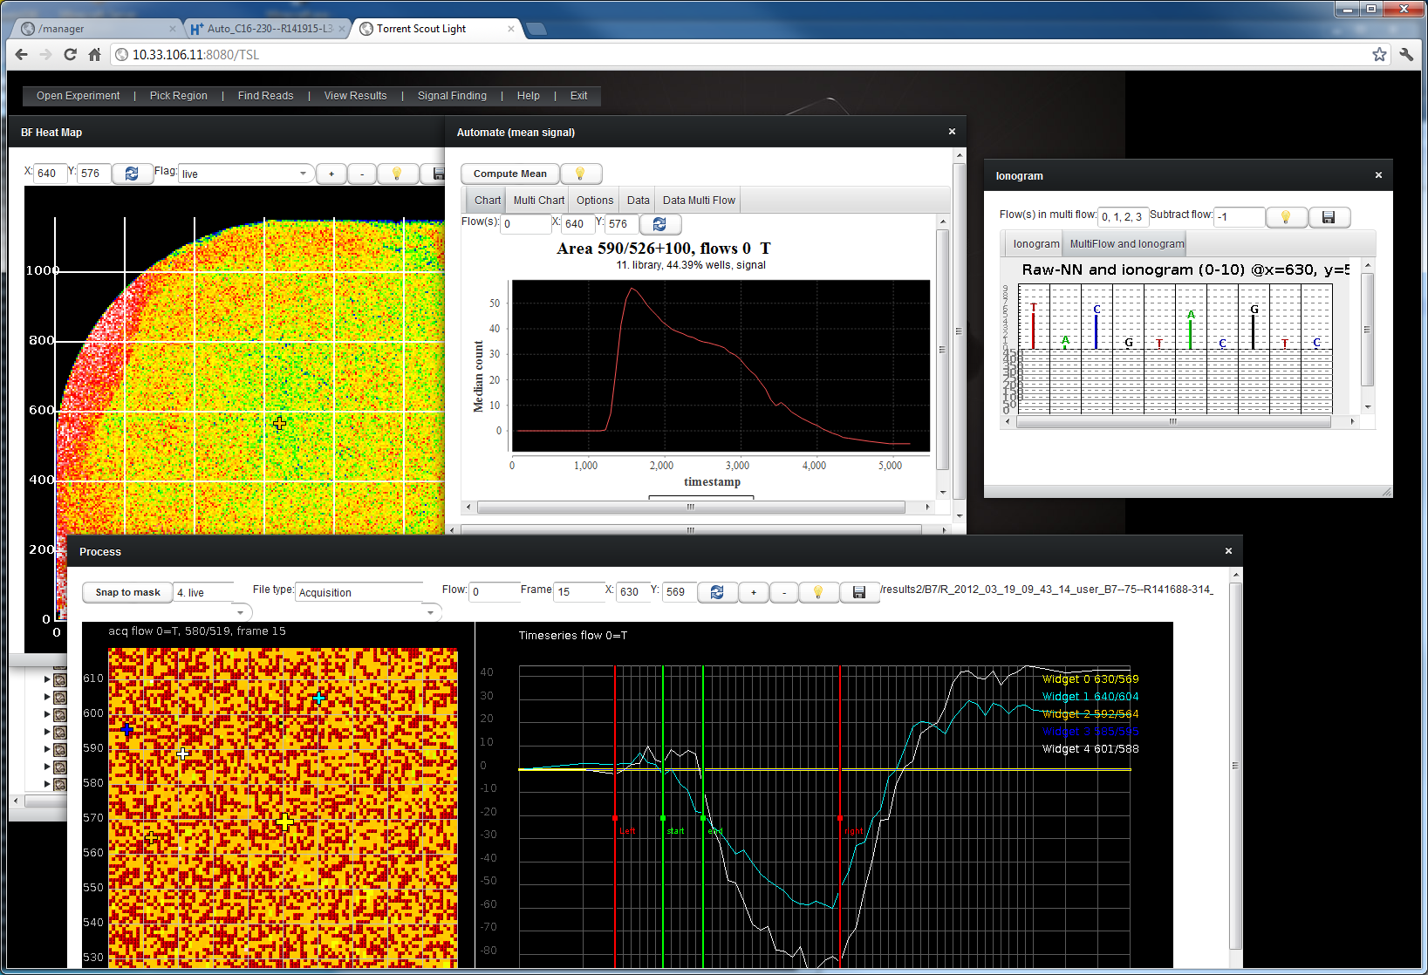

Contents

Open An Experiment 3

Pick a run 3

Top Menu Bar 3

Experiment is opened 4

Finding Reads 6

Finding reads with a certain number of indels 7

Find reads by alignment substrings 9

Raw Traces 13

Working with Raw Data 15

Process Component 15

Fit Component 16

Mean Signal 17

Export to Excel 21

Beadfind 21

Math with masks 22

Exporting lots of raw data (multiple wells, multiple flows) 23

Opening (older experiments) via DB Browser 24

# Open An Experiment

## Pick a run

* Open a browser and point it to a report page such as:
* <http://blackbird.bev/output/Home/Auto_IB6-146-r24433-kw-2ndrun_816_tn_1954/Default_Report.php>
* Scroll down to Torrent Scout plugin section

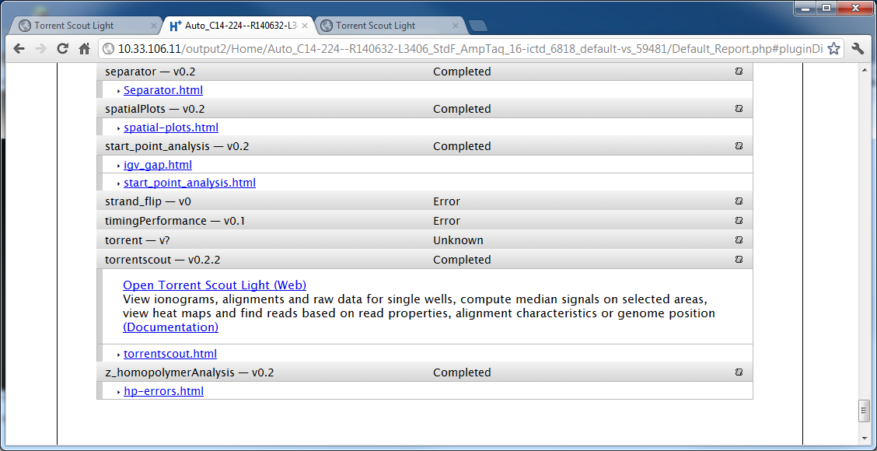

* Click on View results in Torrent Scout Light (Web)
* If there is no Torrent Scout plugin section (if the plugin has not run for this experiment), can do either:
  + Select the plugin Torrent Scout to run (should take about 10 minutes to run depending on chip size and load of the crunchers)
  + Or you can open the experiment via DB Browser (see further down), by starting TSL directly by entering this url:  
    <http://blackbird.bev:8080/TSL?restartApplication>

## Top Menu Bar

* When TSL is started, you should see a menu bar (image below)
* All the components can be selected via the top menu bar
* The top menu has a help button with information about each component and with a link to a .PDF with more information:



* It helps other users if you exit when you are done, so that the server can yield resources quickly (memory)
* Note: if the top menu bar ever disappears (it happens sometimes when the window is too small and lots of things are opened), just zoom out with the mouse wheel (Ctrl-Wheel) and you will see it again

## Experiment is opened

* After you select an experiment and click ok, the bf heatmap opens automatically if a bfmask.bin file is available:

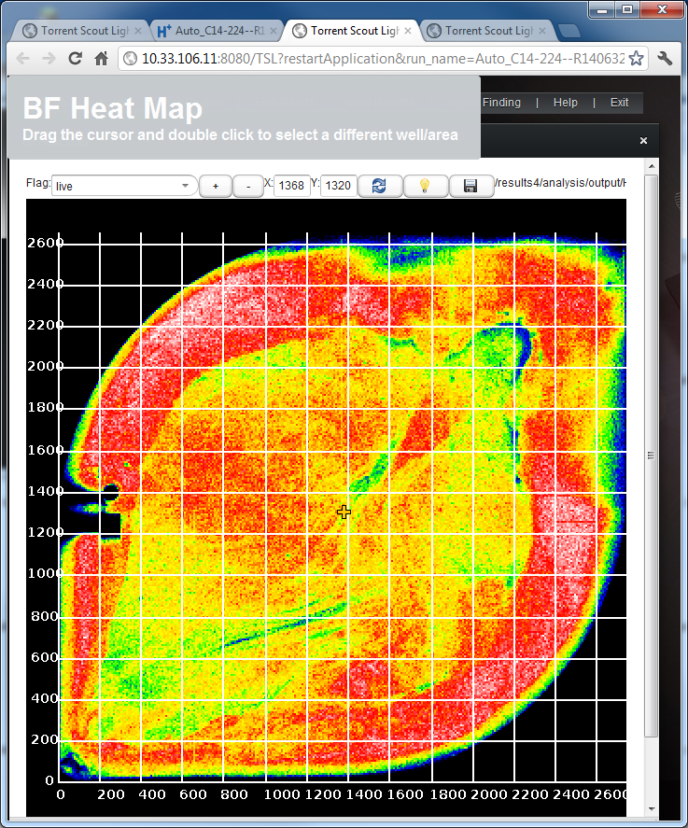

* Each component has a help (light bulb) icon that gives you information about what you can do, and the currently selected experiment (and depending on the context additional information), example:  
  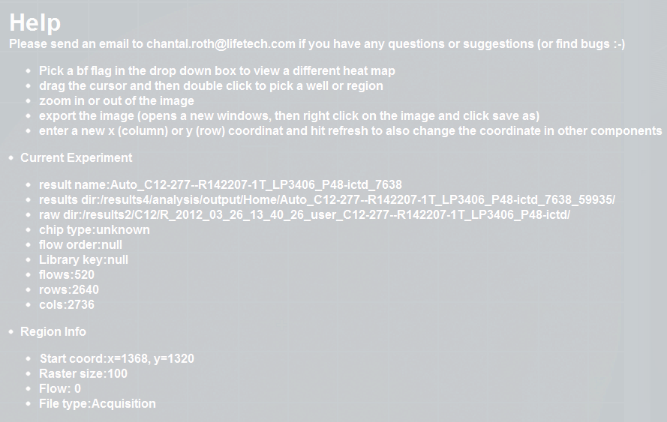
* In this component, you can pick various heat maps, for instance to see where the duds are, pick the dud heatmap:

### Viewing individual Wells:

To view single wells for a given heat map, open the Well Table:

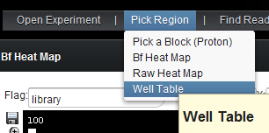

By default it shows the wells around the center. If there are less than 5000 wells in the heat map, it will show all of them.

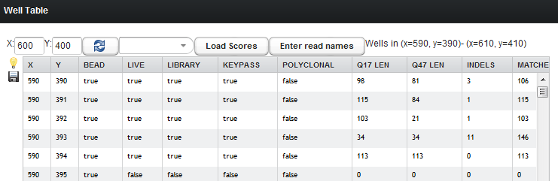

**Note: To pick another area of interest, just click into the heat map**

The table is sortable and clickable. Let’s view the ionogram of a well:

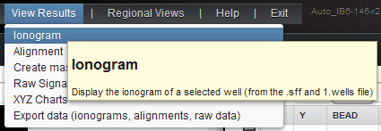

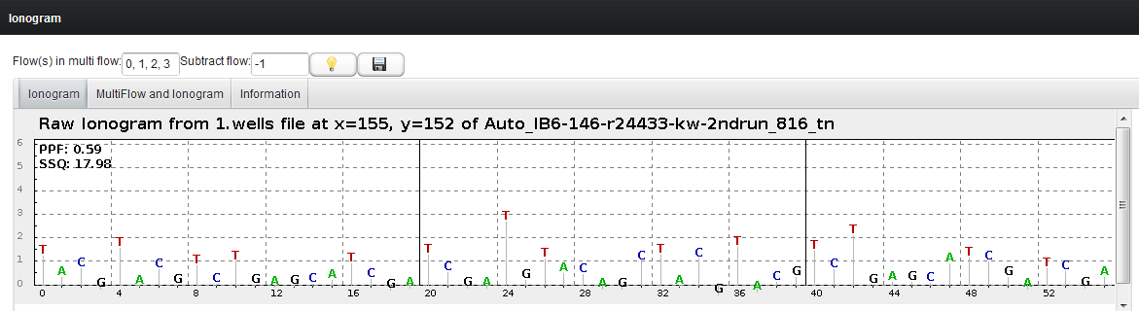

* If raw data is available, then you can use the second tab in the ionogram to view the raw traces of a selection of flows.
* Open the second tab of the ionogram and enter a flow range, such as 36-40:  
  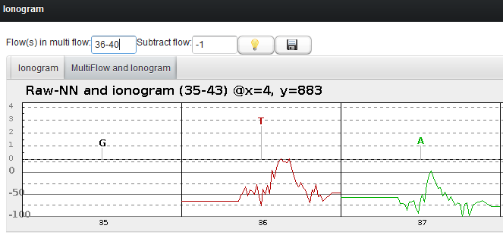

To view the raw signal of one single flow for one single well, let’s try the “Raw Signal” in View Results:

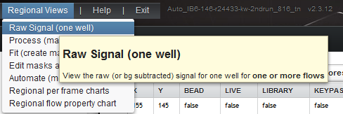

Enter the flow number that you wish to see:

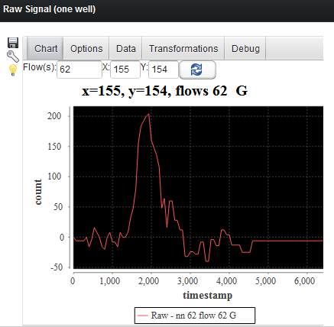

You can also enter multiple flow numbers:

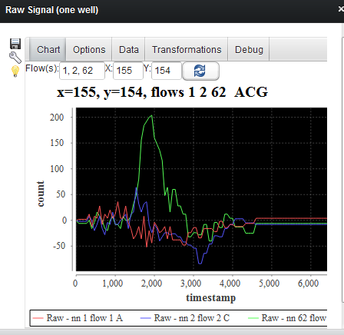

Or you can subtract a zeromer flow from all the other flows to get a better bg subtraction:

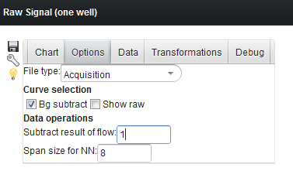

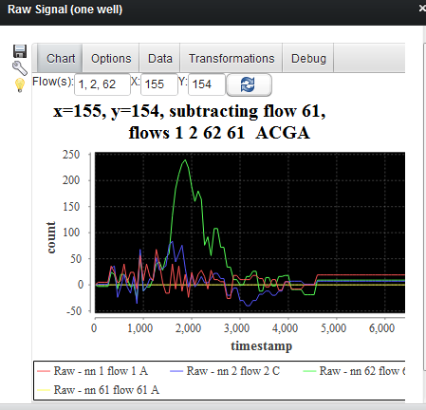

In most components, you can export the image and the data!

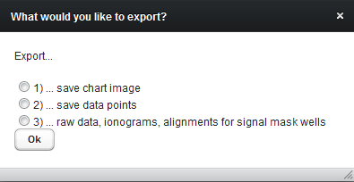

The data is stored in .csv format, so you can use it for instance in Excel.

# Finding Reads

* Select Find Reads/ Find reads by scores and alignment
* Pick the heat map with the indels as an example  
  (Note: some heat maps say “no data”. This may happen if either the plugin has not run and not computed heat map, or if certain analysis files, such as separator.h5, are not part of the results of the run)

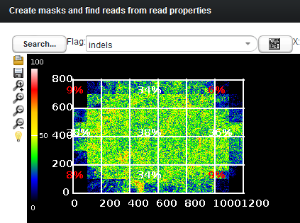

You can zoom in with the + button on the left:

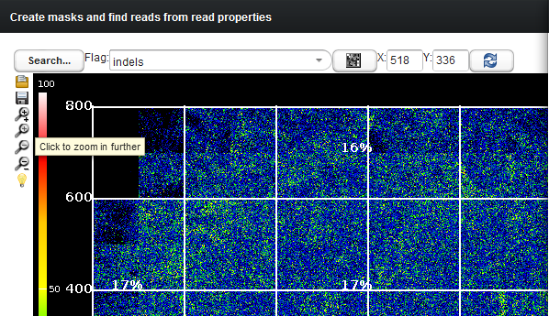

If you click anywhere, the table will show only wells with read that have indels in the area you clicked:

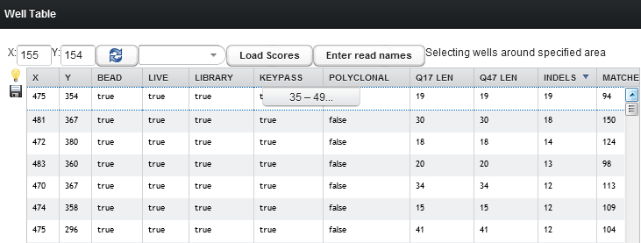

Again to view ionograms and the alignment, just pick a well. Let’s look at an alignment:

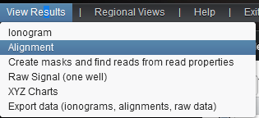

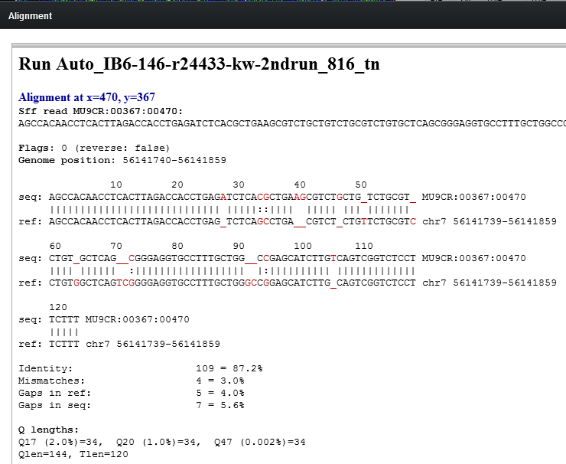

**Note: not all wells have an alignment!**

## Finding reads with a certain number of indels

First a very **quick** way to search reads (but not flow specific)

* Click the search button:

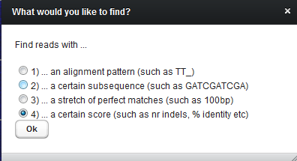

* Pick the 4th option to filter by nr of indels
* Enter a range:

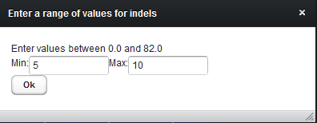

* You should get a result within about 10-20 seconds at most
* Note that the table now only show results that satisfy the search condition. So you only see rows in the table with an indel value of at least 5

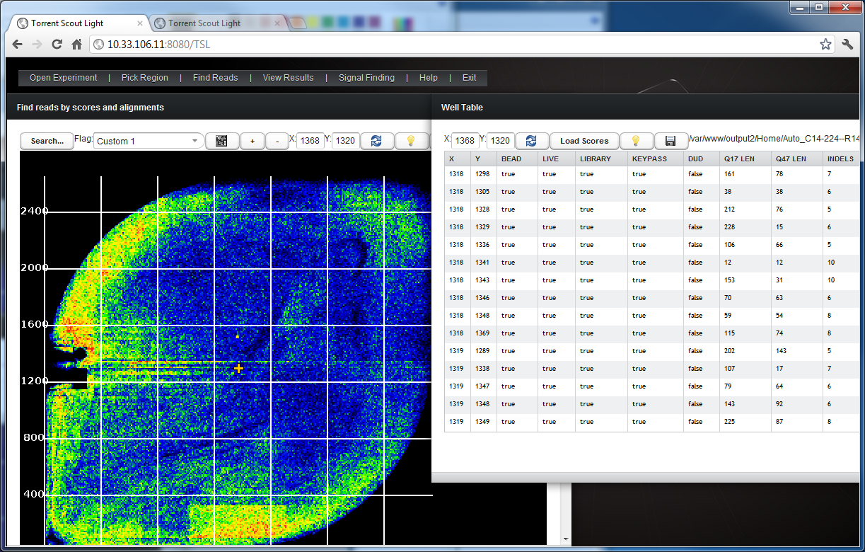

* Let’s pick a read and look at more detail. Click a row in the table.
* It says “well selected” but nothing else happens
* So let’s open a viewer in “View Results”. Open both the ionogram and alignment viewer
* This now automatically loads the data of the well we have selected:

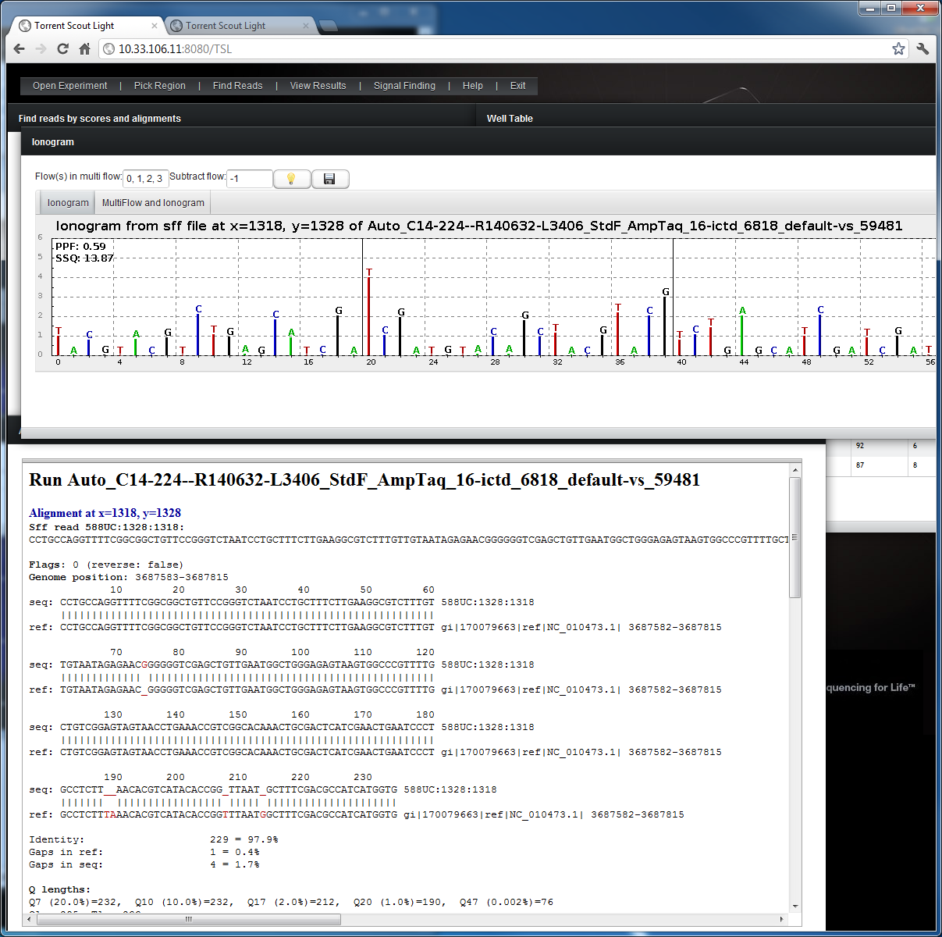

Note that if the experiment has no raw data, then you cannot view the raw signals or use the second tab in the ionogram, or use the automate/process components.

## Find reads by alignment substrings

The first search was quick but not very specific. Let’s search by alignment string and also by flow number.

* Click the search button again:

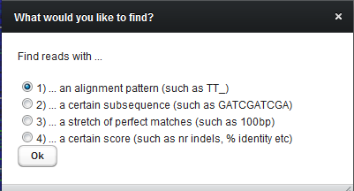

* Pick the first option (alignment)
* Enter an alignment pattern of interest, such as: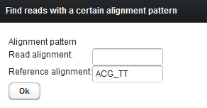
* This will find any alignment where the reference alignment sequence contains ACG_TT (and the read sequence contains any string, most likely ACGnTT)
* You can also enter a flow range:

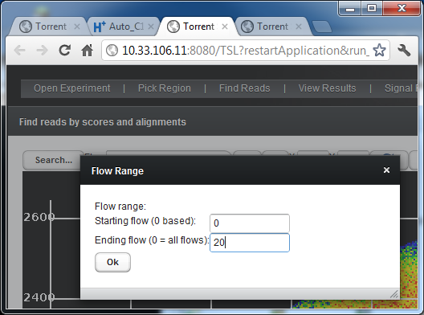

* **Note**: The search takes about **1 minute per million reads** (so for 318 chips, this can take **about 10 minutes**, and for 316 chips about **5 minutes** , and Proton **thumbnails** take about **1 minute**)
* If the result contains < 5000 data points, all results are shown in the table. Otherwise, the data where the cursor is will be shown (and it’s surrounding area)

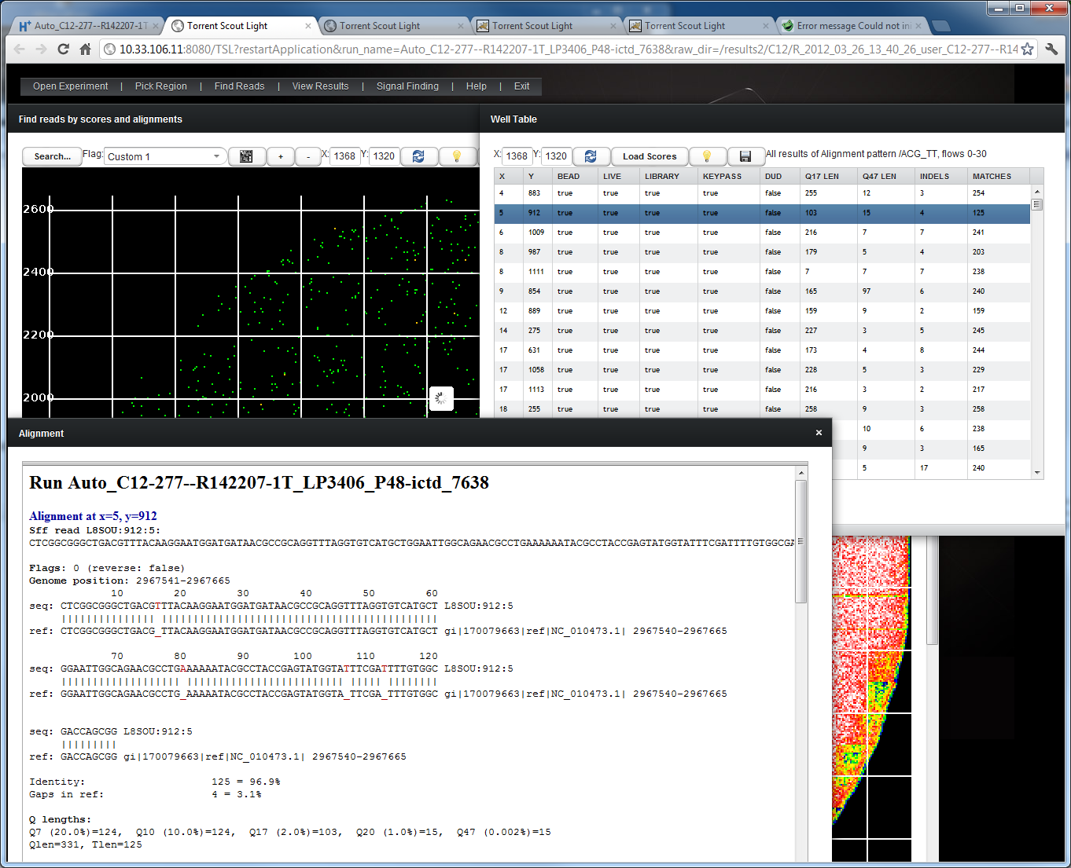

* Since those searches take a while, you might want to save the result (in case your session expires, for instance).
* Click on the save button: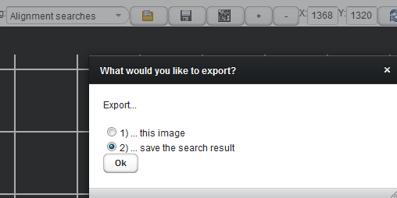
* In the file browser, click “new file” and enter a file name ending with .bmp:  
  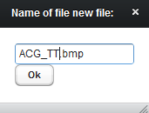
* The mask button in the search window lets you save he search result in a mask that can be used in the Process, Mask and Automate component (for instance if you want to export the flows of that mask in an entire area).

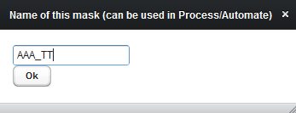

* You can now view the ionograms and alignments of individual wells by selecting a row in the table.
* The table can be sorted by clicking on the header, and you can export the data with the save button. (The load scores button loads the Q17 and other scores if not shown)
* You can also view the wells of a certain region by picking a mask in the drop down box, including your own masks (but only in a certain region, as it would otherwise result in too many rows :-)

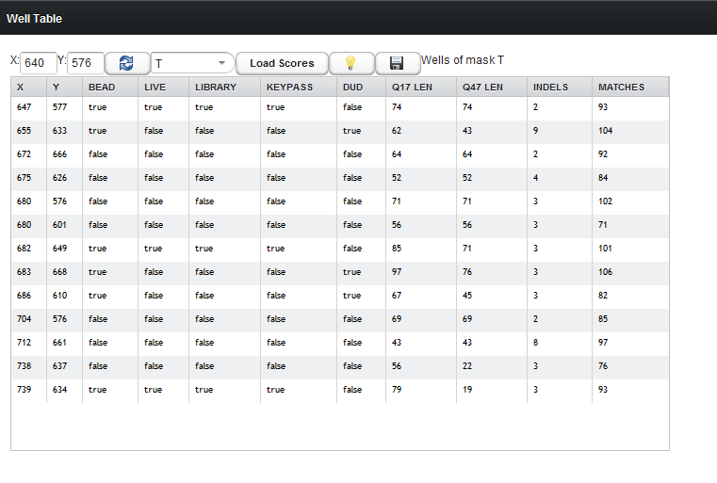

With the save button, you can also export the table data to another program such as Excel:

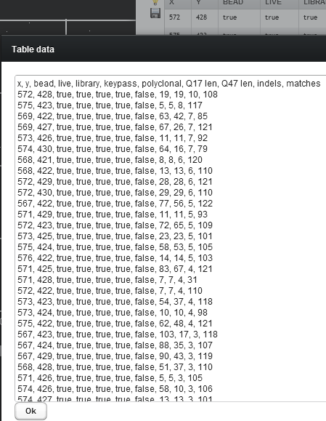

# Regional Empty Traces

You can view both the average empty traces for the various regions, but you can also see the raw traces for wells with a certain flag (such as keypass)

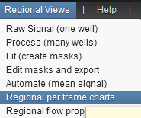

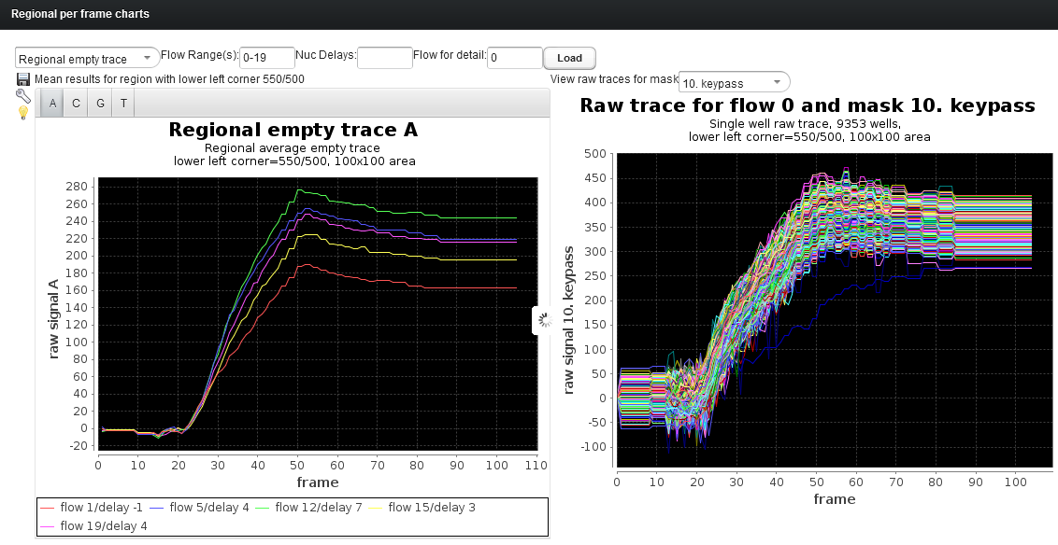

You can see the different step sizes for the different nuc delays. On top, you can pick flow ranges, pick specific nuc delays (multiple are possible here!), and you can also pick certain flows.

On the right, you view the raw data for single wells in that area for a given heat map (such as live or keypass or empty etc)

With the save button, you can export images, charts and other data!

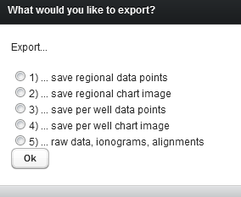

# Regional Flow Properties

The next menu item lets you view regional flow properties. The one currently implemented is step size for all flows:

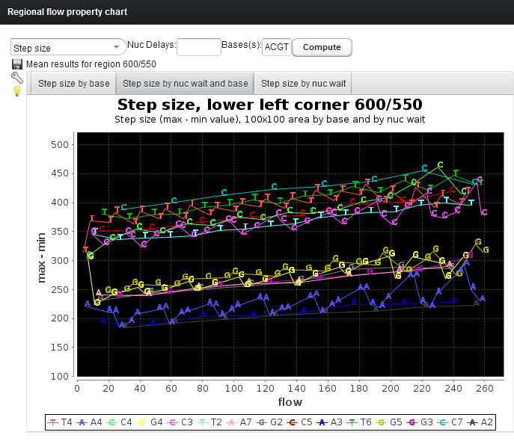

On top you can filter by nuc delays or bases. Say you only want to see the step size for the Ts:

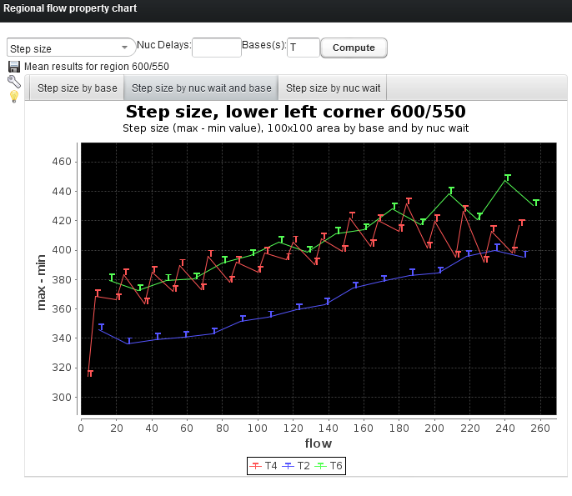

# XYZ Charts

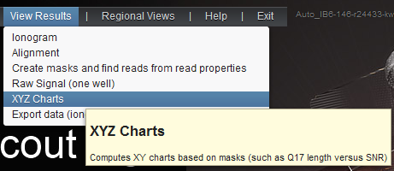

This component lets you view the relationship between any two properties, applied to any given mask!

For instance, maybe you want to see the SNR (signal to noise ratio) versus PPF (average nr of incorporations per flow):

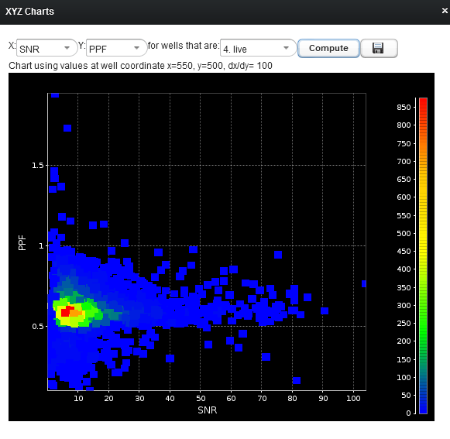

Or maybe you want to see the Q20 length versus the signal to noise ratio:

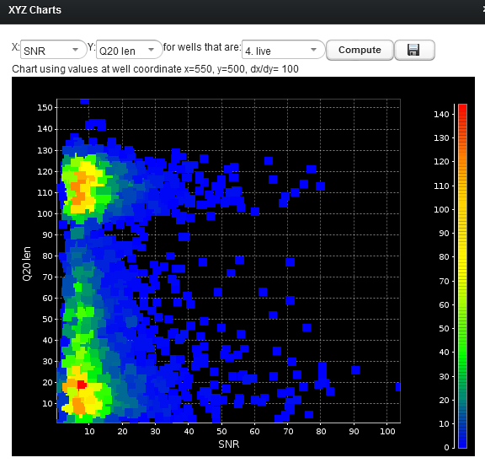

**Note that you can click into the chart, and it will show you all wells that match these values in the table!**

The top right of the table always shows you what exactly is in the table. In this case, all wells with that given SNR and the selected Q20 length (approximately, +- a small amount as it puts all the data into buckets ).

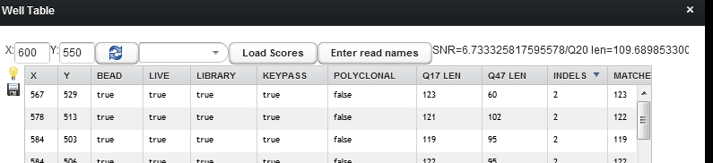

Note:Some of the properties say “**no data yet“.** In this case, the reason is that there is no separator.h5 file for this run! If you wish to have this data available as well, you can use **--beadfind-diagnostics 1** in the run configuration

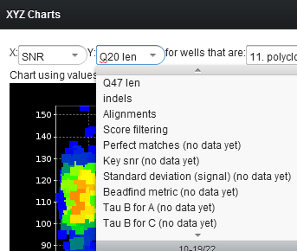

Again you can export all data points to a .csv file:

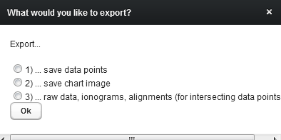

Example:

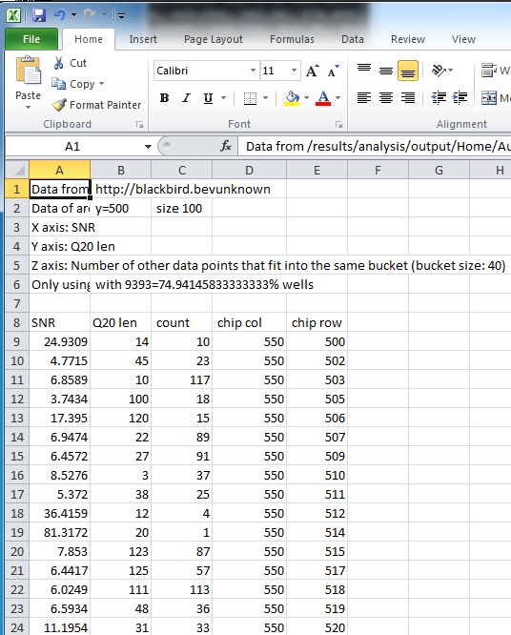

# Working with Raw Data

More detailed look at flow 36, let’s open the process component:

## Process Component

* Enter flow 36 (and any frame you like).
* The fat yellow line is the T of well 4/883
* The other lines are signals from other random wells in that area

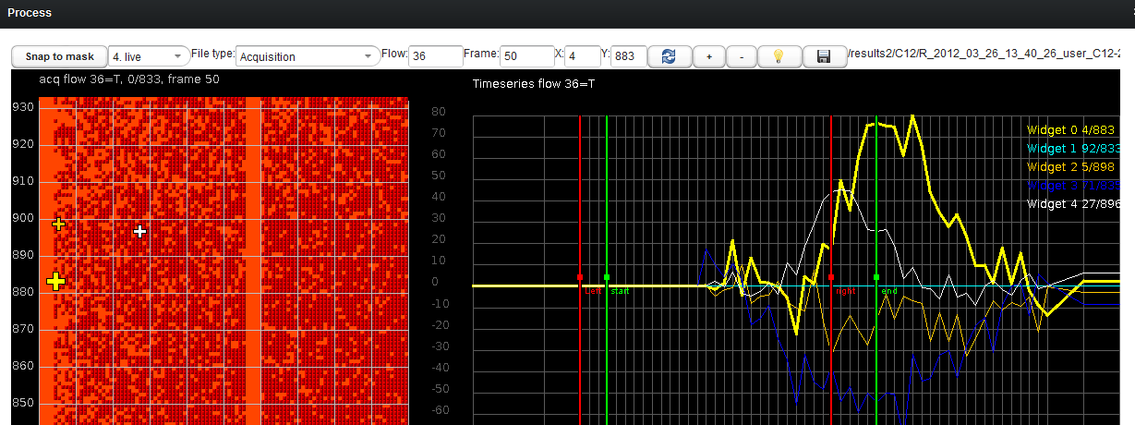

## Fit Component

* Let’s find other wells with a large T signal:
* Move the green vertical bars around the signal
* Recompute the histogram – now wells with a large T signal are on the right
* Values on the left mean small integral (poor signal)
* Click into the histogram to see example wells of either large or small T signal:

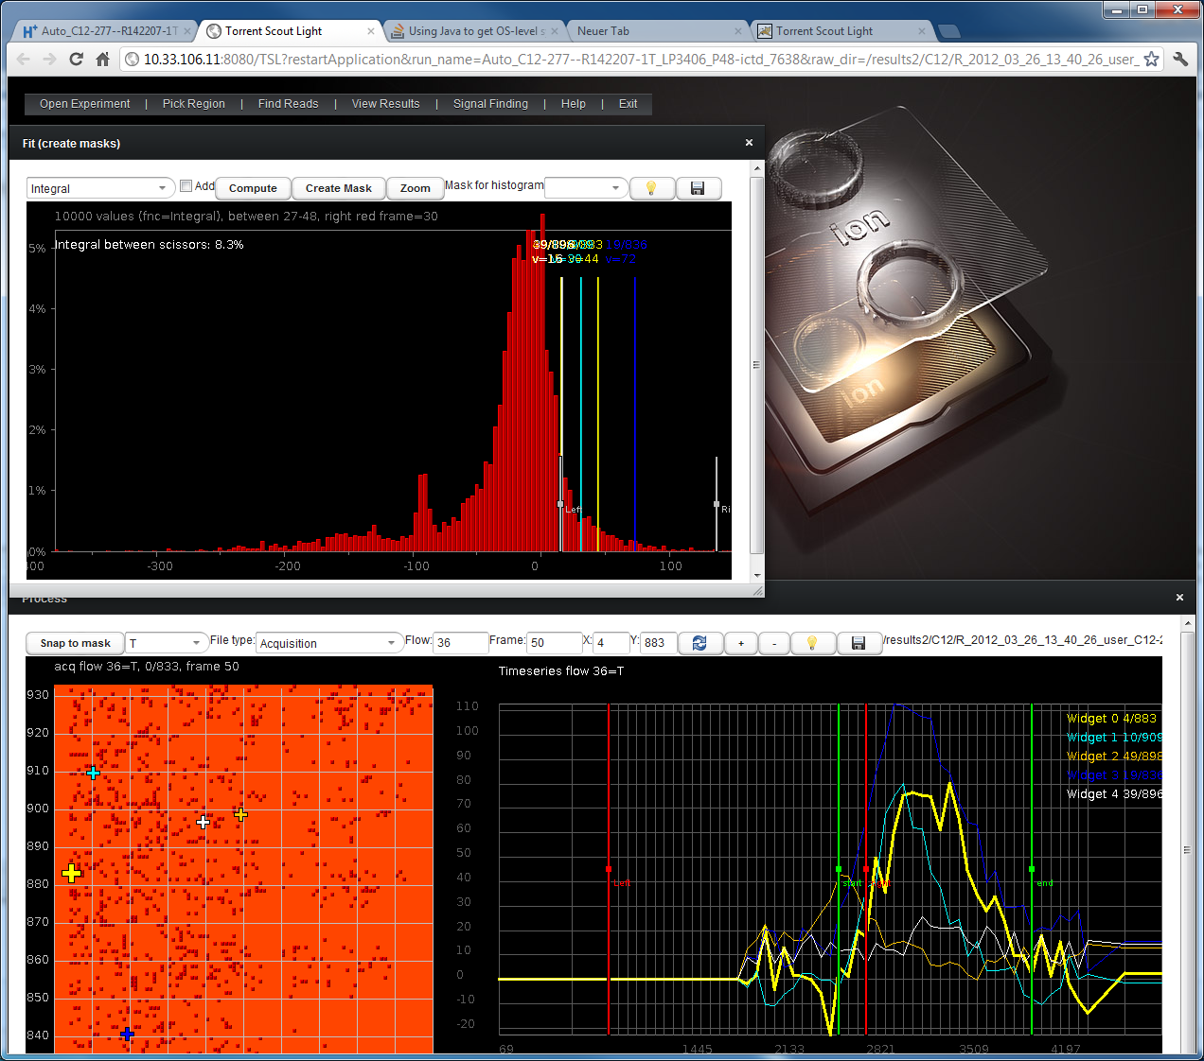

* Move the left/right bar in Fit to where you think the large T signal is
* Click on create mask and name it something like T_signal  
  Enter a name for the new mask:  
  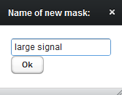
* You can view the mask in the Process (and Mask Editor):
* Now we have created a mask with all wells with a large T signal in the area
* In Process, pick that new T mask and snap the cursors to it
* Now we can see only wells with a large T signal

## Mean Signal

* Select Automate to compute mean signal in an area  
  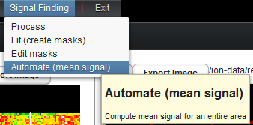
* This opens the mask, process and Automate component:
* We can now compute the average signal of flow 36 for the wells with a large T signal:
* Pick the T mask as signal mask
* Click on Compute Mean in Automate Component:

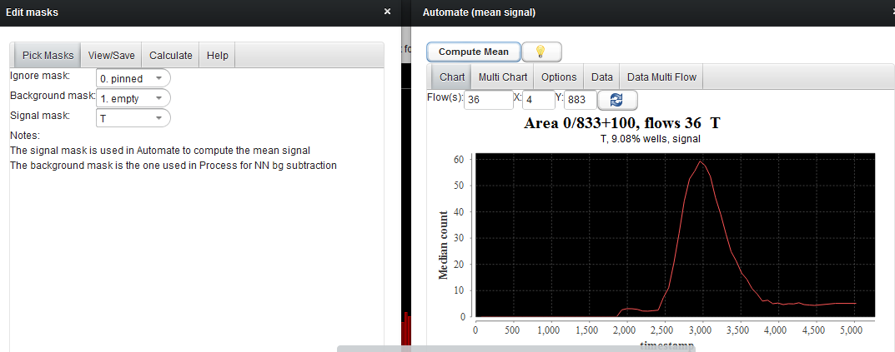

* You can also enter multiple flows. Enter 0-4, and click on Compute Mean again:  
  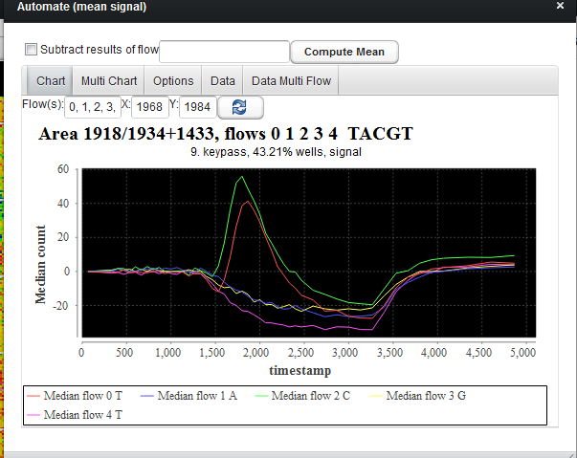
* Select the MultiChart tab to see the flows after one another:  
  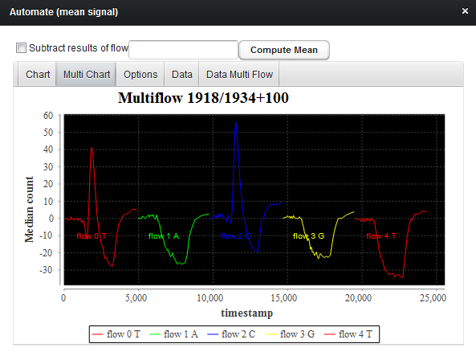
* The data tabs contain the data that you can copy/paste into Excel:

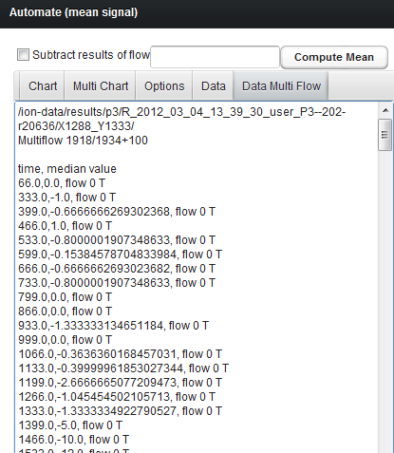

* Open Excel, select “Paste/Use Text Import Wizard…”

## Export to Excel

* In the Text Import Wizard, use **comma** as separator:  
  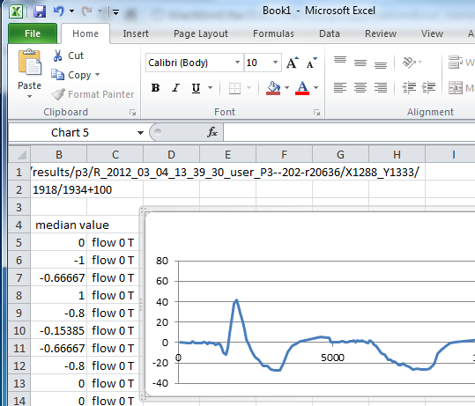

## Math with masks

* Maybe we want to combine or subtract masks to create our target mask – open the Mask Editor and select tab Calculate:  
  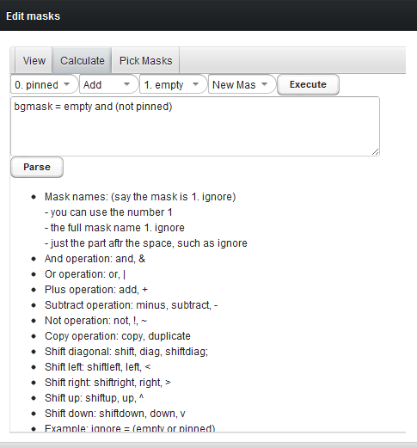
* Let’s create a mask with all bf wells, but with a signal smaller than our “large signal” mask:
* Pick Bead in the first drop down box
* Pick subtract as operation
* Pick “large signal” as second mask
* Hite execute
* Enter a name for the mask

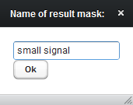

* If you wanted to type it in, you could enter:

Small signal = bead – large

## Exporting lots of raw data (multiple wells, multiple flows)

The Process component lets you store either raw or NN subtracted raw data for an entire area for any number of flows:

* Lets export the wells with a large T signal of flow 36
* Go to the Process component, select the T mask
* Click save  
  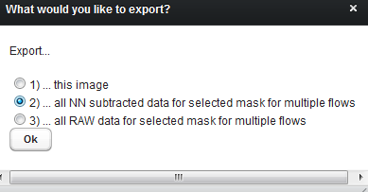
* Pick the flows to export. Here we pick 36 only:
* 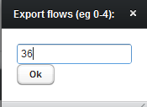
* Now you can use this data in Excel or Matlab in any way you want  
  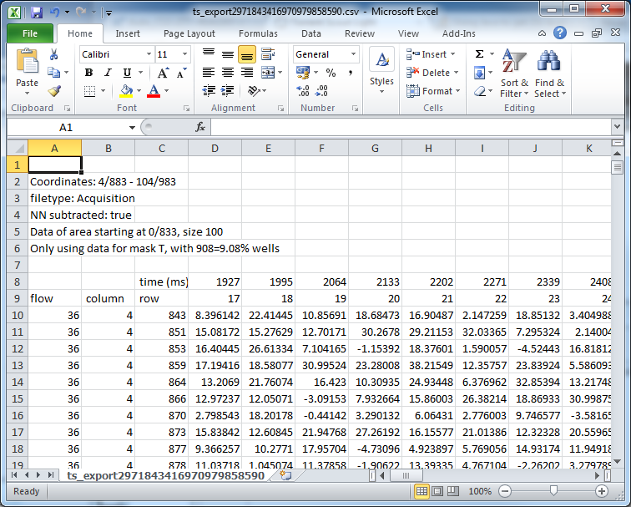

# Opening other experiments

Let’s open a full proton experiment!

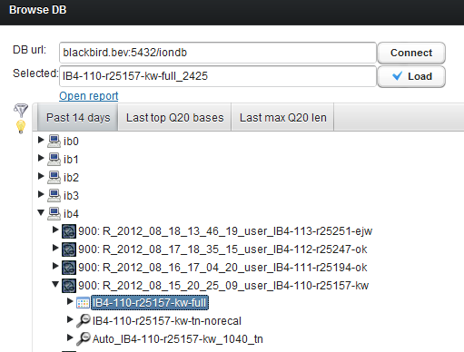

It might warn you that some files are not there, but for a full proton experiment, there may not be one large .sff and .bam file, which is ok!

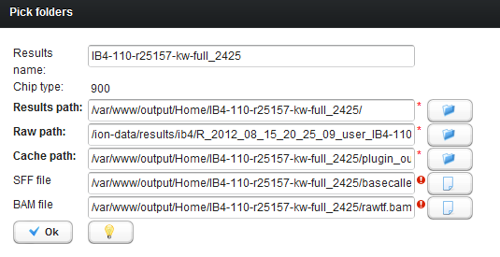

For other experiments, if it can’t find the sff file- or if you want to open an experiment that is local to your hard drive and is not in the database, this window lets you specify the locations of those files.

Note: if the Torrent Scout plugin has not run, it will have to do a lot of the computations and indexing on the fly! It will stil lwork, but it could potentially take several minutes for instance to compute the full Proton heat maps. It is more convenient to just enable the torrent scout plugin to make sure it does all the computations.

You might see this if it has not run the plugin:

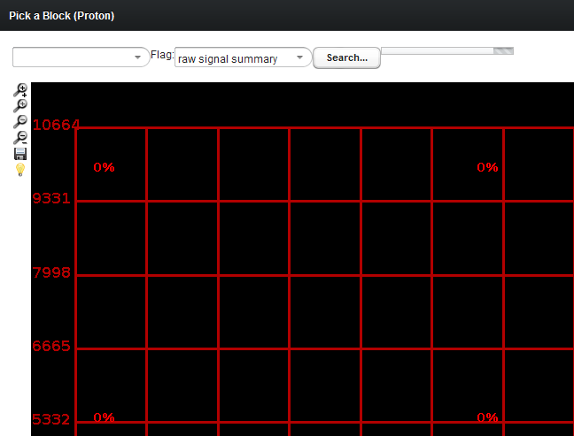

You can still pick a block by clicking into it, or by picking a block from the drop down box!

When it has computed the heat maps, this is what you should see:

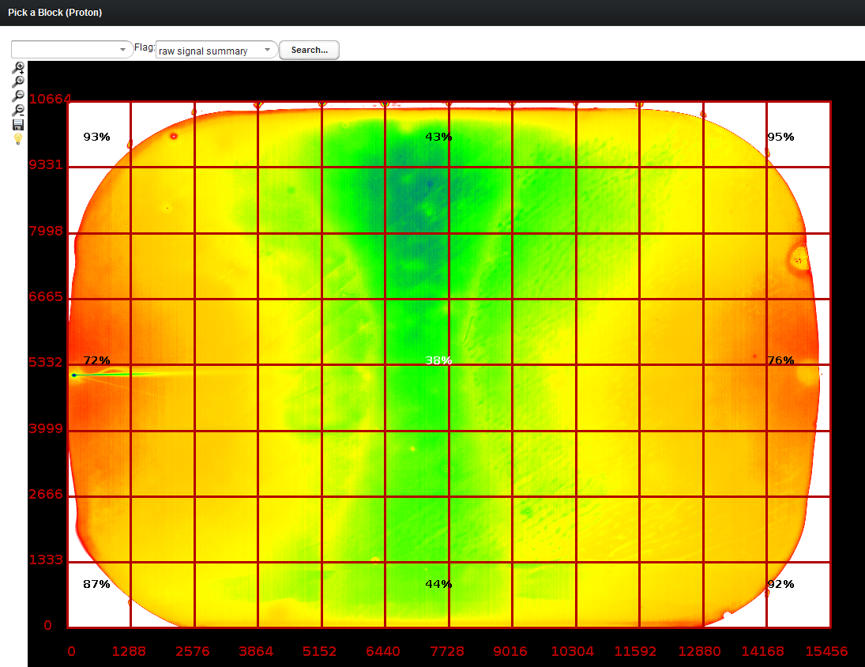

You can pick another heat map, such as live:

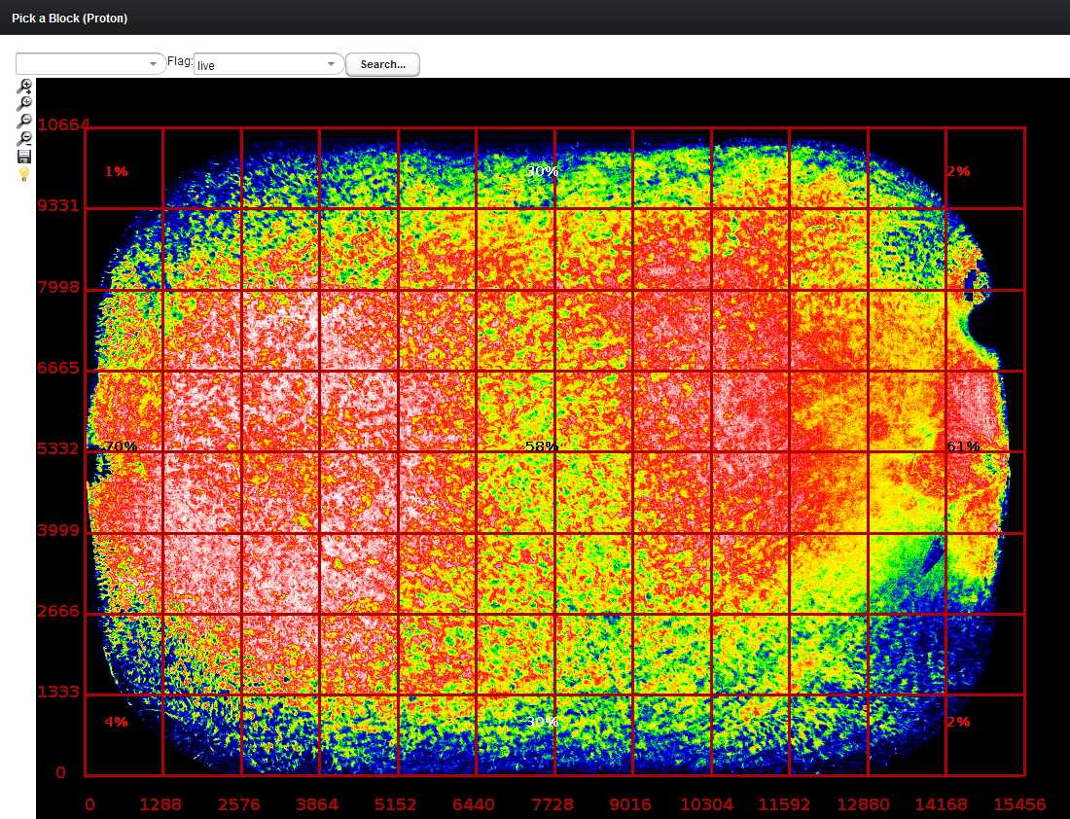

Or you can of course pick problematic heat maps, such as polyclonal:

When you click into a block, you can then view this part of the proton experiment in all detail as before!

# Full Proton Searches

You can also search the entire proton chip for alignment patterns, and view the results interactively!

Click search, and enter a pattern:

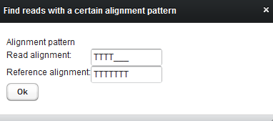

Note: if you enter short patterns, this will result in millions of search results!

**Note: full Proton searches take at least 10 minutes!**

It will however update the screen after it has search each block, so that you can see the progress, and you also have the option to stop the search ☺. (Click on the **stop search** button on top to do that).

To view the search result of a particular block, just click on it, and it will automatically show you all wells that match the search pattern!

## Opening (older experiments) via DB Browser

By default, the browser only shows you experiments of the past 14 days or so. To open older experiments, click the **filter** icon to see older experiments or to search for an experiment by name:

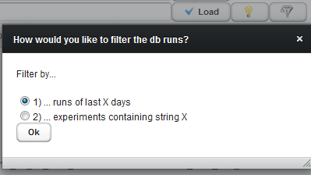

When prompted, enter a value such as 60 for the past 60 days:

Now the older experiment shows in the list:

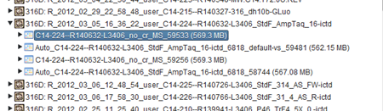

Note: when you click on an experiment or run, an info message shows you more details about it.

# Offline Alignment Searches

On the fly alignment searches may take several minutes. In particular if you want to run multiple searches, it may be more convenient to run the searches offline, via Torrent Scout plugin:

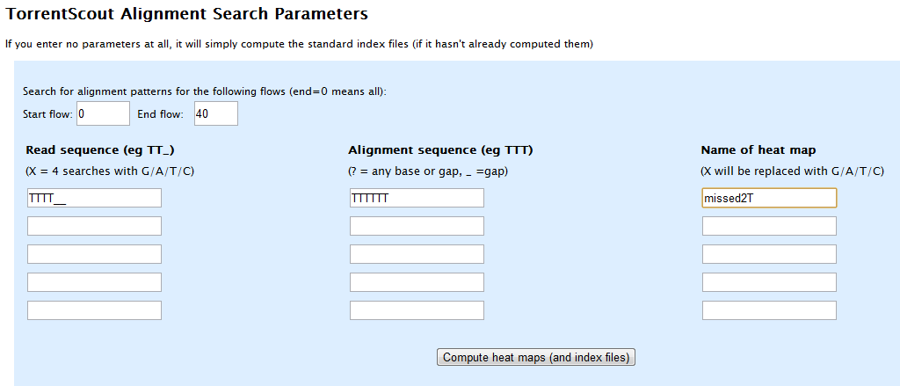

When the search is complete, it will show the result in a heat map for each search. To view the data interactively in Torrent Scout, click “Open Torrent Scout Light”.

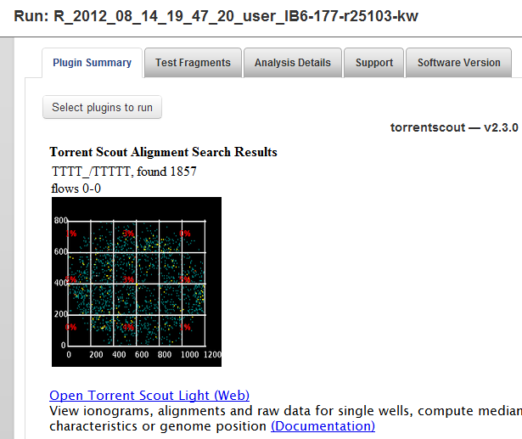

# Known Issues:

## Memory: Internal Error

The code runs on the server. If multiple users are using it at the same time, the program may run out of memory. This will result in an “internal error”. Please let me know if this happens (I might have to restart the server). If this occurs a lot, we can increase the amount of memory we give it!

## Session Expired:

If you start TSL and go off to lunch, your session will most likely have expired when you get back! You can increase the time in the Help section however, for instance of you run a long search.

However, if you do run long searches a lot, let me know and I will add it to the plugin instead!

## Menu on top disappears

This happens if the open windows extend the browser area. To see the top menu bar again, zoom out and back in with the mouse wheel ☺